Electronic Funds Transfer (ACH) Authorization
Kontaktmission USA
PO Box 825
Humboldt, TN 38343-0825
(731) 784-9422
office@GoKMUSA.org
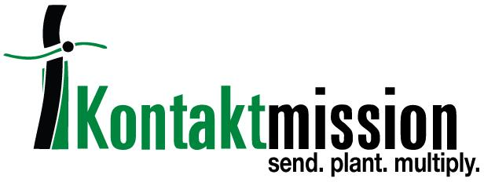
Please print out this form. It requires a signature.

I hereby authorize Kontaktmission USA to charge my account each month the amount shown below (this includes my authorization for Kontaktmission USA to reverse any charges made in error). This authority will remain in effect until I give written notice to cancel or change it. I understand that it can take up to three weeks after Kontaktmission USA receives the information before the first electronic gift can be processed and that it can take up to three weeks to process changes.

This form is for a:

_____ New authorization _____ Change of information

Amount per month $___________ Monthly transfer date: ____1st ______15th (check one)

(Minimum $10.00 per transfer. If no preference is indicated, transfers will be made on the 1st of each month.)

Special instructions/requests, designated for, etc.

- ROBERSON FAMILY | - ROBERSON MINISTRY

Please include a voided check (not a deposit slip) with this signed form and mail to:

Kontaktmission USA
PO Box 825
Humboldt, TN 38343-0825

We need to be able to reach you in case of a transaction problem. Please provide all this information:

E-mail: ______________________________________________

Name________________________________________________ Phone ( )_________________

Street________________________________________________________________________________

City_________________________________________ State___________ Zip _________________

Signature__________________________________________________ Date __________________

